Report of Project 3: Signal processing in Medical Images
Anomaly Detection of CT images

Authors Name/s per 1st Affiliation (Qin He)
data engineering and machine learning
TUT
Tampere, Finland
Qin.he@student.tut.fi

Abstract—Digital mage processing more and more useful in medical, biology and physics etc. fileds, We thus here use some basic digital signal processing methods combining some algorithms to help make the CT medical images easier to read by the doctor as well as develop the application to help the doctor to annotate the anomalies. For example, tumors, cancers and deceases.
Keywords—Matlab, Noise average, mean filter, spatial domain and frequency domain enhancement, sharpening, image restoration and degradation.

Introduction
Image/video processing is a useful tool to describe or analyze the results, report, code, input and output images/videos. Nowadays, the digitized CT images are of various layers, detailed representation of the objects and high isolation. Recently, some frontier theories (fuzzy maths, topologies and artificial intelligence etc.) ^{[1].}
This report generally applies some basic techniques of the intensity transformation, spatial filtering and image smoothing and sharpening on frequency domain, image restoration and reconstruction on the medical CT images. Additionally, we also use the color detection way develop a tool for doctors to annotate the part of the images they want. For example, the detection of the anomalies (cancer, fraction and tumors etc.)

Related Work

Noise Processing (averaging and mean filter)
When images are displayed, they often have suffered from noise and interferences from several sources. The noise effects can usually be removed by simple ad hoc “noise-cleaning” techniques applied to local neiborhoods of input pixels. In comparison, I also utilize one type of the mean filter to smooth the noised image. ^{[2]}

Mask and Spatial Domain transformation
Spatial domain operation or filtering (the processed value for the current pixel processed valued for the current pixel depends on both itself and surrounding picels.)^{[3]} Hence Filtering on spatial domain is determined by applying some algorithm to the values of the pixels in one certain center and it’s neiborhood correspondingly. In this report, both linear and nonlinear filter is utilized. In addition, mask will be defined in the color detection.

Intensity Transformation
Intensity transformations are among the simplest of all image processing techniques. The values of pixels, before and after processing, will be denoted by r and s respectively. Because we are dealing with digital quantities, results of the transformation function typically are stored in a one-dimensional array and the mapping from r to s are implemented via table lookups^{.[2]} In this report, we use the power law filter and log filter comparatively to study their effects of the change of intensity on CT images.

Sharpening on Frequency Domain.
The principal objective of sharpening is to highlight transitions in intensity. Uses of image sharpening vary and include applications ranging from electronic printing and medical imaging to industrial inspection and autonomous guidance in military systems.
Basically, Fourier’s contribution in this field states that any periodic function can be expressed as the sum of sines and/or cosines of different frequencies, each multiplied by a different coefficient. It does not matter how complicated the function is. If it is periodic and satisfies some mild mathematical conditions, it van be represented by such a sum. Even functions that are not periodic (but whose area under the curve is finite) can be expressed as the integral of sines and/ or cosines multiplied by a weighing function. ^{[2]}
In this report, we use the sobel and Laplacian filters to detect the anomalies of the disease parts.

Image restoration
As in image enhancement, the principal of restoration techniques is to improve an image in some predefined sense. Although there are areas of overlap, image enhancement is largely a subjective process, while image restoration is for the most part an objective process. Restoration attempts to recover an image that has been degraded by using a prior knowledge of the degradation phenomenon. Thus, restoration techniques are oriented toward modeling the degradation and applying the inverse process in order to recover the original image.^{[2]}
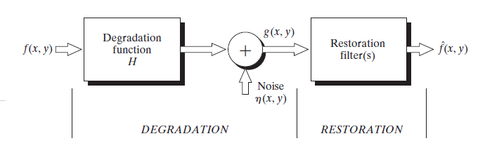

As the degradation process is modeled in the below as a degradation function that, together with an additive noise term, operates on an input image f(x,y) to produce a degraded image g(x,y). The restoration approach used in this report is the geometric filter and inverse filter.^{[2]}

Color detection and Annotation
Accurate localization and identification of vertebrae in spinal CT imaging is important for many clinical tasks such as diagnosis, surgical planning, and post-operative assessment. Thus, in this report, we change gray-level CT into colored RGB images to annotate the spine CT^{[2].}

Algorithm

A1. Average noise
Consider a noisy image:
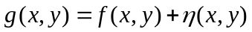
Where the second term is noise which is uncorrelated with the second term is noise which is uncorrelated with the input and has zero mean. Then, averaging K different noisy images:
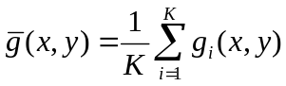
Produces an output image with:
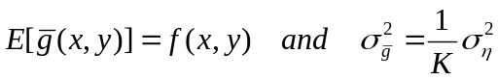
After averaging the noise, the variance deceased with K times. As K increases to infinite, the noise can be ignored.
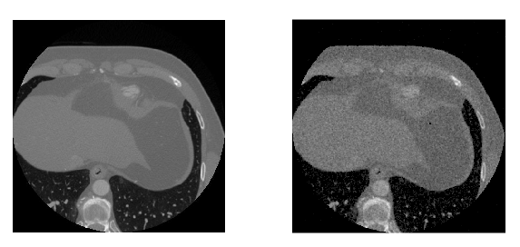
Figure A1 left (a) origin , right (b) noise averaging of brain CT1.
As adding 10 noises with (a), the result after averaging is as the right. It is smoother than the original one.
The elapsed time is 1.603595 s.

A2. Geometric filter
Assume the only degradation present in the image is due to noise:
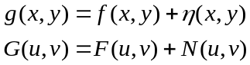
This brings us back to the enhancement problem encountered earlier.
Here, the Geometric mean filter is applied:
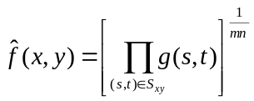
Among all the common used mean filter, the geometric mean filter is comparable with less loss of image details.
Compare to the noising average, geometric filter is usually faster.
The elapsed time is 1.335591 with the batch size to be 3*3.
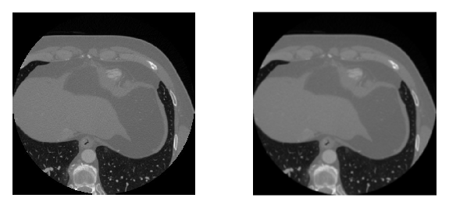
Figure A2 left (a) origin, right (b) geometric filter of brain CT2.
The elapsed time is 0.739039 with the batch size to be 3*3(less loss of image details).

B1. Gaussian High-Pass filter
The Gaussian high-pass filter (GHPF) has this form:

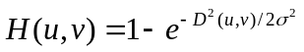 where 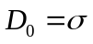
σ is a measure of the spread of the Gaussian curve
recall that the inverse FT of the GLPF is also Gaussian, i.e. it has no ringing!
At the cutoff frequency D₀, H(u,v) decreases to 0.607 of its max value.

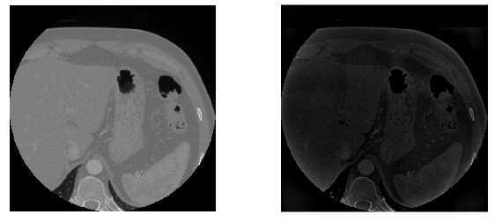
Figure B1 left (a) origin, right (b) Gaussian high-pass filter (order 1) of brain CT2 with cutoff frequency distance as 15.
The high frequency part is reserved and thus the result is darker than the origin one.
The elapse time is 0.568928 seconds.

B2. Butterworth High-Pass filter
Transfer function of a BLPF of order n, and cut-off frequency at distance D₀ (at which H(u,v) is at half its max value) from the origin^{[2]:}
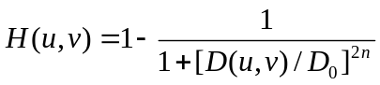
Where
The BW filter-pass is looser than the Gaussian filter-pass filter thus the result is not as good as the Gaussian filter.

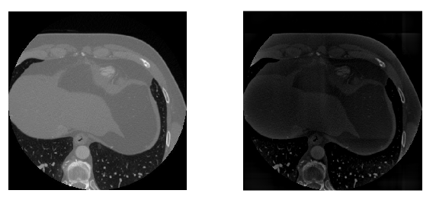
Figure B2 left (a) origin, right (b) Butterworth high-pass filter (order 1) of brain CT2 with cutoff frequency distance as 12.
The elapse time is 1.136337 seconds.

C. Histogram-Equalization filter
To transfer the gray levels so that the histogram of the resulting image is equalized to be a constant:
This figure shows that for any given mapping function between the input and output images, the following holds:
i.e., the number of pixels mapped from x to y is unchanged.
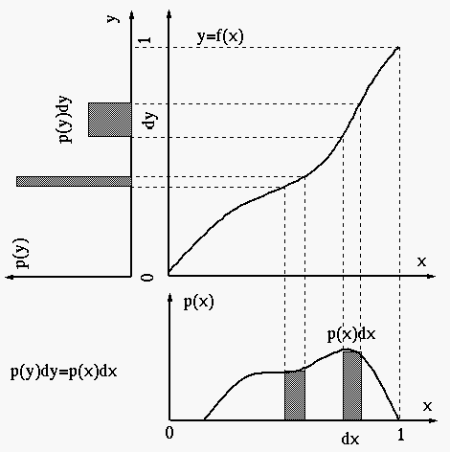
Figure C histogram equalization

The purposes^{[2]:}
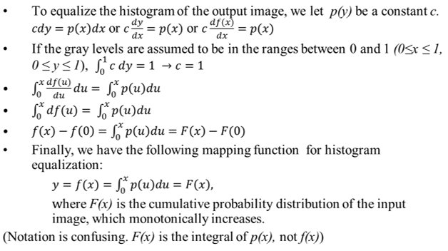
  - to equally use all available gray levels;
  - for further histogram specification.

D1.Log Transform
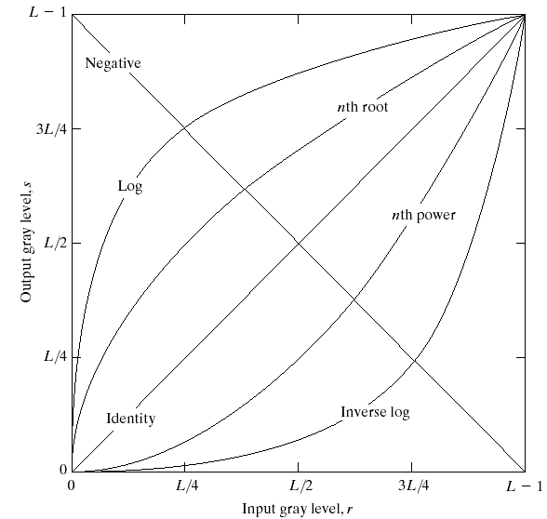
Figure D1 spatial filter
s = c log(1+r)
c is a constant and r ≥ 0.
This transformation maps a narrow range of low gray-level
input values into a wider range of output levels^{. [2].}
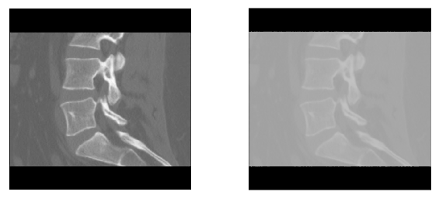
Figure D1 left (a) origin, right (b) log transform of spine CT with c=35
Expand values of dark pixels in an image while compressing higher level values

D2.Power Law Transform
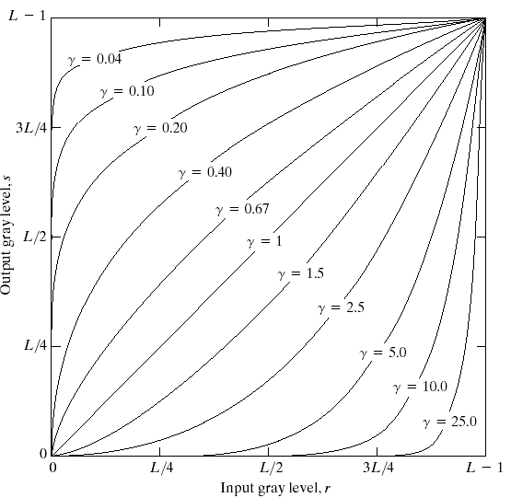
Figure D2 Power Law Transform
s = cr^{γ} (c and γ are positive constants), where gamma correction^{[2]}

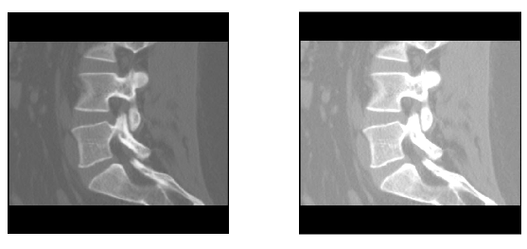

Figure D2 left (a) origin, right (b) Power Law of spine CT with c=1.5 , γ=1
Details in the image are enhanced.

E1.Sobel Operator

First derivatives are implemented using the magnitude of the gradient. The gradient (which is linear) is given by^{[2]:}
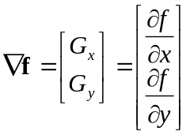
The magnitude of the gradient:
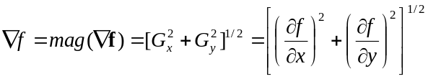
Which has the faster appprocimation:
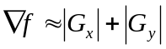
Operators:
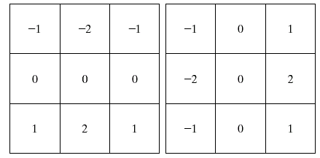

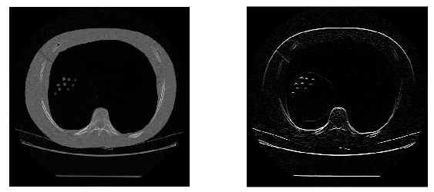
Figure E1 left (a) origin, right (b) Power Law of spine CT with c=1.5 , γ=1

E2.Laplacian Operator

Isotropic 2nd order derivative (Laplacian):
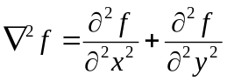
In digital form:
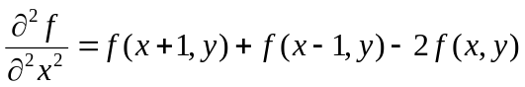
in the x-direction and in the y-direction:
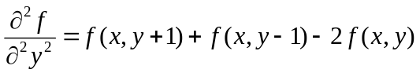
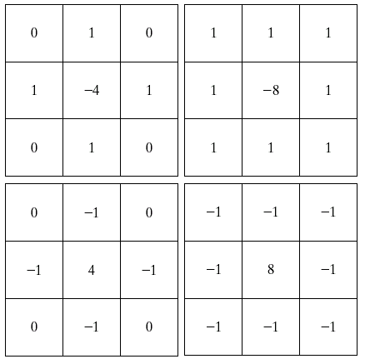
Enhancement using Lapacian:
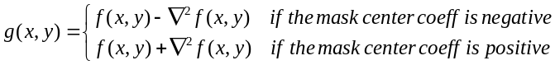

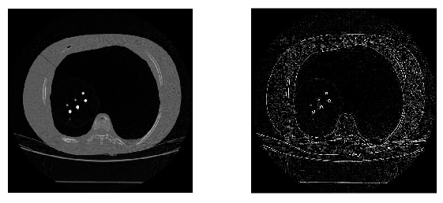
Figure E2 left (a) origin, right (b) 2nd order Laplacian transformation with A=4.7

As the second order derivative, it has the stronger response to details because it has a stronger response to a line than and a step and to a point than to a line.
F.Color Detection
Choose the pixels of grey level values within r distance, and than transform the grey level pictures back to RGB image format.

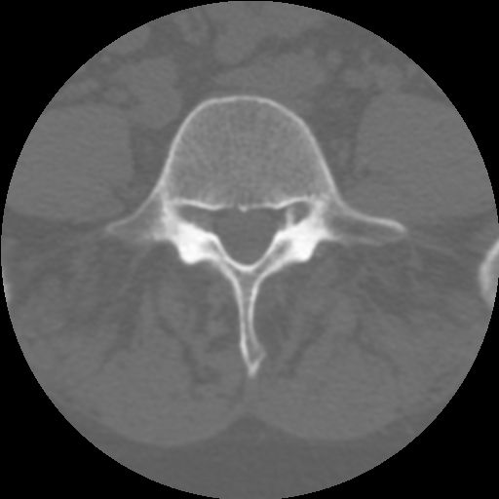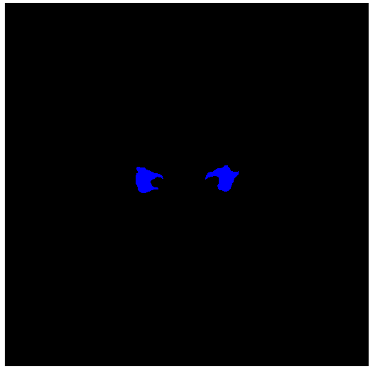

Here, we annotate the anomalies by color blue.

G.Inverse Filter

Inverse filtering is to reverse the effects of system.

Assume that we have estimated H using any of the previous
techniques. Let’s try now to restore the image^{[2]}.
In the absence of any information concerning noise, we get:
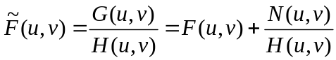
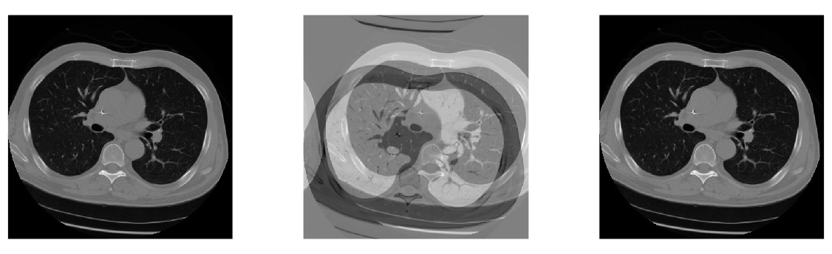
Figure left (a) origin of brain CT (b) middle, Fourier Transform of filter, blurring (c) right, Power Law of brain CT with inverse H, where r=0.1.

Experimental Results
Single technique may not produce desirable results, we thus combine spatial enhancement, intensity transformation, color & annotation and restoration. This application may be utilized to detect anomalies. For example, deseases, bone infection and timors etc.
Object: To enhance this image by sharpening it and by extracting out more of the skeletal detail.
Strategy:
- Use gradient sobel operation to depict edges
- Then Laplacian operation to highlight details
- Restore the CT images to decrease noises,m especially the blur.
- Apply power law transformation to further enhance the interested anomalies.
- Detect the anomalies and annotate them.
Note: Median filtering is a nonlinear process thus can not be used in medical image processing. We here choose the Gaussian High Pass Filter. Laplacian, being a second-order derivatives has better effects in smoothing the image and enhancing details but it will also bring about more noises than the gradient. Thus we apply inverse filter after it before the last step of the processing, power law intensity enhancement.

Spatial Enghancement
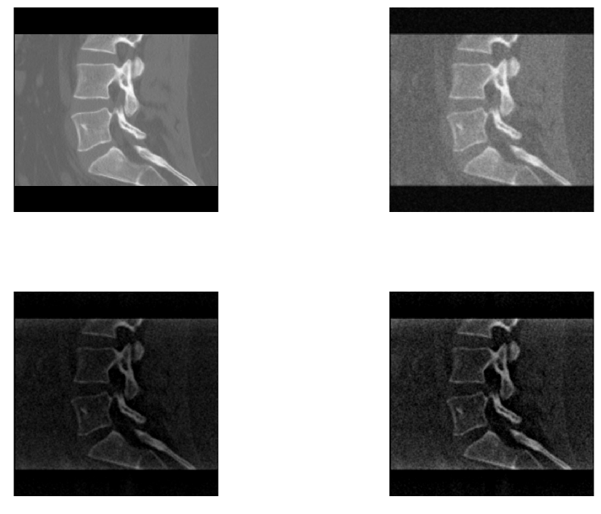
Figure A sharpening: upleft, (a) origin, upright, (b) sobel, downleft, (c) Laplacian, downright, (d), (Sobel+origin) x origin
Discriminably, Laplacian gives better results if the original image is darker than desired and it’s detection of details is generally better than Sobel. The decease parts of the spine is enhanced.

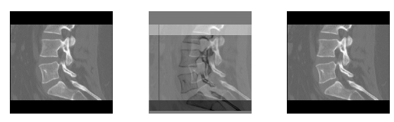
Figure B degradation and restoration: left (a) origin of spine CT (b) middle, Fourier Transform of filter, blurring (c) right, Power Law of spine CT with inverse H, where r=0.1.
CT may have nonlinear noise because of the sensor during image acquisition and after the spatial transformation, we thus use inverse filter to restore and degrade it.

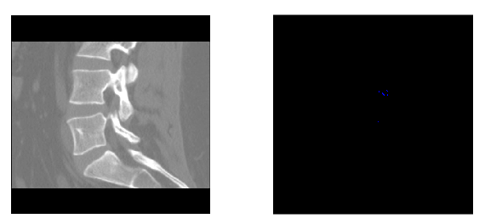

Figure C detecting and annotating: left (a) power law transformation, right (b) color detect and annotate.
After the power law transformation, the details can be more easily read by the doctors and. In this application, the anomalies can be annotated by clicking two points in the interested field.

Conclusion

In this report, we develop the application of some common used techniques in image processing, combing the algorithms of Average noise, Geometric filter,Gaussian High-Pass filter, Butterworth High-Pass filter, Histogram-Equalization filter, logrithm transformation, power law transformation, derivative operators, Laplacian operators, inverse filter and color detection and annotation.
It is clear that, the Geometric filter is of least information loss among all the mean filters which remove most of the noises. The Gaussian High-Pass filter let more components pass than the BWHP and thus basically has no ringing and blurring. Histogram equalization adjust the intensity obviously. Power law transformation and sharpening operators both enhance the details. Inverse filter help to restore and degrade the image noises because of image acquisition or intensity transformation. Last, the color detection help the doctor to annotate the anomalies on the CT conveniently.

Acknowledgment
The brain CT images used here are provided by Connell Uniersity Vision and Image Analysis Group: http://www.via.cornell.edu/databases/
and the spine CT images are provided by Spine Web: http://spineweb.digitalimaginggroup.ca/spineweb/index.php?n=Main.Datasets#Annotations

References
- Tang. Wang, B. Christ, and LP, Xiang, “The current situation and meaning of the CT image processing,”. 35 pp. 418-455, April 1989
- Rafel C. Gonzalez, Richard E.Woods,’Digital Image Processing, 3rd edition.’ Upper Saddle River, NJ 07458.
- A.Occorenzalns Digital Image Processing , 4th ed., vol. 2. Springer: John, 1995, pp.70-76.

